APA citation Style

APA Format Citation
APA (American Psychological Association) in-text and reference list citations. This easy-to-use, comprehensive guide makes citing any source easy

Core Components of an APA Reference:

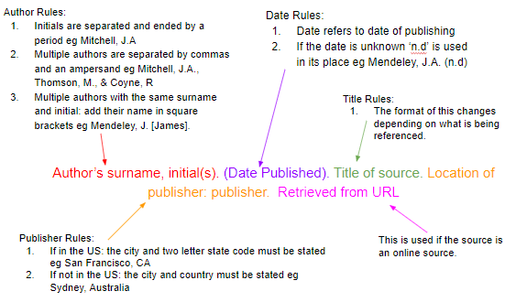
Example:
Derwing, T. M., Rossiter, M. J., & Munro, M. J. (2002). Teaching native speakers to listen to foreign-accented speech. Journal of Multilingual and Multicultural Development, 23(4), 245-259.
https://www.mendeley.com/guides/apa-citation-guide/

